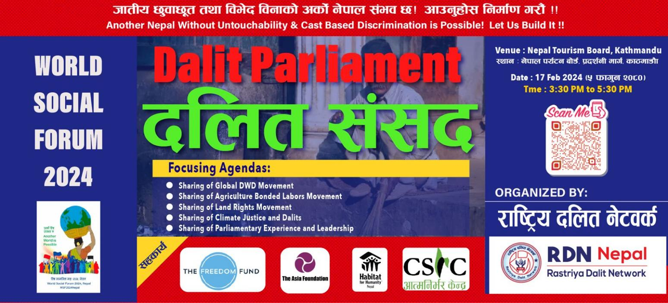
Dalit Parliament focusing on the issues of Agriculture Bonded Labors in the context of World Social Forum (WSF) Nepal-2024

Proceeding Report

Prepared By:
Rastriya Dalit Network (RDN)-Nepal
Dhangadhi sub-metropolitan City –5, HasanpurDhangadhi, Kailali
Contact: +977-91520604 (Office) Email: rdnnepal@yahoo.com
(Liaison Office, BijuliBajar (Opposite side of Prabhu Bank, Kathmandu)
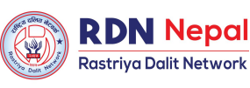

What is Dalit Parliament?

Dalit parliament is a common platform of Dalit activists, the leaders of all political parties and the well-wishers or supporters of Dalit rights movement aiming to bring historically prevailed Dalit issues in rigorous discourses and create significant pressure for state bodies. The practice of Dalit parliament has been initiating since 2001 and it has been conducting every year. Dalits in Nepal has been oppressed economically, socially, culturally and politically from the history long. Despite their significant contribution in national economic development, they are overlooked at the time of power sharing. Due to the initiation of Dalit parliament in Nepal, the concept of Asian Dalit Parliamentarian Forum on Dalit Concern has come into existence. Similarly, model constitution assembly, People SAARC, Poor's Parliament, Parliament on Natural Resources, Youth Parliament are taken into consideration.

Objectives of Dalit Parliament
- To create mass conscientation among Dalits and other marginalized communities; freed Harawa-Charawa, Haliyas, Kamaiyas and Kamhlaris (Agriculture Bonded Labours) on national and international Human Rights Instruments.
- To share the experience and method of Dalit rights movement of Nepal with globe
- To share the experience of land rights movement of South Asia
- To raise the awareness among other World Social Forum (WSF) actors especially on Dalits Human Rights and climate justice as well as social justice.

Impact of Dalit Parliament
The first Dalit Parliament was organized in 2001 and it could provide the pressure for the election of constituent assembly in time. Likewise, the second Dalit parliament was held in 2002 and it proclaimed the meaningful peace negotiation and alternative report for constitutional reservation for Dalits. In the same way, the third Dalit parliament was conducted at Dhangadi in 2003 that widely advocated for the emancipation of Haliyas and revolutionary land reform. But the venue of Dalit parliament from the forth Dalit parliament was shifted to Kathmandu and it proclaimed the model constitution of democratic republican Nepal. Similarly, fifth Dalit parliament in Kathmandu proclaimed the federal democratic republican Nepal. In the same way the sixth and seventh Dalit parliament formed shadow constituent assembly through designating Dalit parliament as Dalit constituent assembly to provoke for constitutional national Dalit commission as well as for drafting the forthcoming constitution in Dalit perspective.Similarly, 8th, 9th and 10th Dalit parliament focused on constitution building and 11th Dalit parliament raised the issues for implementing the newly promulgated constitution of Nepal.

Focused Agendas and Target Groups:

Dalit Parliament directly targeted 370 participants representing from Dalits, women and other vulnerable groups; agriculture bonded labours; freed Harawa-Charawa, Haliyas, Kamaiyas and Kamhlaris. Indirectly, it targeted all Dalits of communities (13.2% of whole population) in Nepal, 100,000 freed Harawa-Charawa of 8 districts in Madhesh province, more than 19,000 freed Haliyas, 32,000 Kamaiyas and 13,000 Kamhlaris in Nepal. The list of the participants is included in the document mentioned below as:

The Dalit Parliament focused on the following agendas as mentioned;
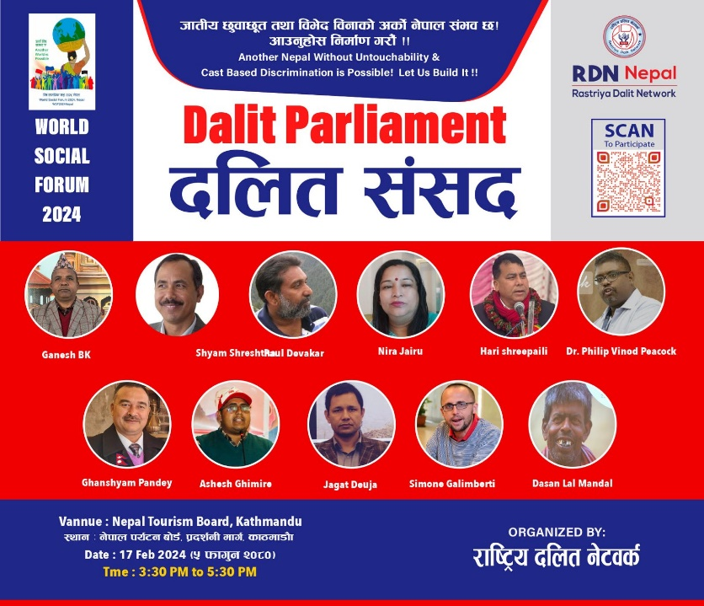
- Spokesman of Dalit Parliament: Mr. Ganesh B.K.
- Agriculture Bonded Labors Movement: Mr. Shyam Shrestha (Coordinator of Agriculture Bonded Labours Situation Study Committee and CA Member)
- Land Rights Movement: Mr. Jagat Deuja (Land Expert and former member Land Problem Solving Commission)
- Discriminated Work and Descent (DWD) Movement: Mr. Paul Divakar (Global Chair of Global Forum of Communities Discriminated on work and Descent)
- Dalit Theology in the 21st Century: Dr. Philip Vinod Peacock (Executive Secretary of Justice and witness of the world Communion of Reformed Churches, Germany)
- Climate Justice & Dalits: Mr. Ghanshyam Pandey (Climate Justice Expert and former chairperson of FECOFUN)
- Leadership Opinion Building: Mr. Simone Galimberti- International Practitioner on Good Leadership, Opinion, writer, Facilitator/Trainer
- Experience Sharing on Parliamentarian: Mrs. Nira Jairu (Former MP of House of Representatives and Coordinator of Implementation of State Directive Principles, Policies and Responsibilities, Monitoring Committee)
- Socialism & Dalits in Nepal: Mr. Ashesh Ghimire
- Mainstreaming of Agriculture Bonded Labours issues in Dalit Movement in Nepal: Mr. Hari Shreepaili

Rationale of Dalit Parliament

Responding to the global trend of shrinking civic space, particularly in Asia, the World Social Forum (WSF) Nepal 2024 was organized from 15-19 February, 2024 at Kathmandu that provided a critical platform for civil society organizations, activists, and human rights defenders. The World Social Forum (WSF) was a global beacon of hope, born in response to the adverse effects of Neo-liberalism. Established in 2001, WSF was a platform for open dialogue, democratic debates, and the pursuit of alternatives to Neo-liberal economic policies. In 2024, Nepal hosts WSF, facilitated by the NGO Federation of Nepal (NFN), which was also functioning WSF Secretariat at NFN.

During the same course of time, Dalit parliament was relevant and fitting under contemporary changeable political and socio-economic context of nation in such a way that Dalits comprise the poorest community in Nepal, in terms of all poverty measures – income, consumption and human development. A total of 42% of Dalits fall below the poverty line which is 17%higher than that of the national average (25.2%). The average per capita consumption in Nepal is 34,187. Similarly, more than 90% agriculture bonded labours: freed Harawa-Charawa and Haliyas represent from Dalit communities. Dalit parliament has become common plat-forum to ensure Dalit rights in new constitution of Nepal.

Date, Time & Venue of Dalit Parliament:

Dalit Parliament was organized on 17 February, 2024 at Kathmandu (Nepal Tourism Board Exhibition Road) from 3:30 PM to 5:30 PM in the context of World Social Forum (WSF) Nepal 2024 with the financial support of the Freedom Fund (TFF), The Asia Foundation (TAF), Habitat for Humanity International Nepal (Habitat-Nepal) and Community Self-Reliance Center (CSRC) in the solidarity of more than 50 civil society organizations and issues based movement in Nepal.

Details of Dalit Parliament:

Conclusion of Dalit Parliament: "Nepal without untouchability and discrimination is possible"

During the 16th conference of the 16th World Social Forum held in Kathmandu with the slogan 'Another world is possible', Dalit community leaders and rights activists from South Asia, including Nepal, have debated in favor of another world without caste based discrimination and untouchability. Not only in Asia, but all over the world, some kind of discrimination persists, they also called for united resistance against it through the World Social Forum. In the event, caste discrimination and its various forms were not only discussed in Nepal, the leaders who came as representatives from the villages also announced that they will now fight unitedly to create a Nepal without caste discrimination and untouchability.

While the World Social Forum is being held in Nepal, the leaders of the Nepali Dalit movement had awakened the 'Dalit Parliament', which was practiced in the Far West before the establishment of the Republic, and the challenge of making laws by discussing and debating in the Dalit Parliament on issues that the sovereign parliament of the state could not do for the human rights, human dignity and self-respect of the Dalit community.

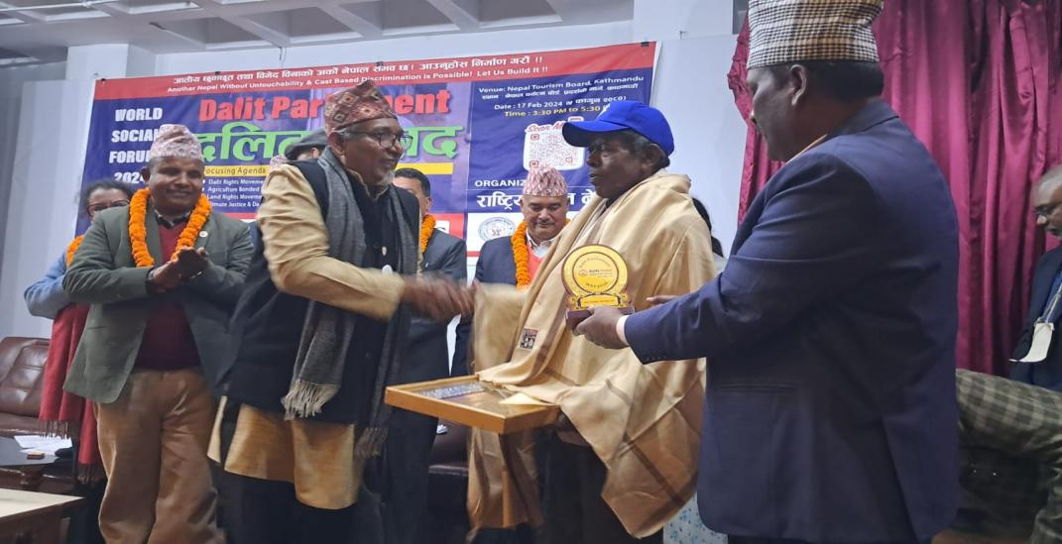
The program was inaugurated by lightening 3 candles. In Zero-time of Dalit Parliment, the voice of voiceless people were raised. Mr. Ishwar Sunar, chairperson of Rastriya Mukta Haliya Samaj Federation Nepal, Mr. Rajwati Mandal, treasurer of national Harawa-Charawa rights forum, Mr. Dasan Lal Mandal, chairperson of national Harawa-Charawa rights forum and Mr. Pashupati Chaudhary, central chairperson of Freed Kamaiya Society expressed their views. During the same course of time, , Mr. Dasan Lal Mandal, chairperson of national Harawa-Char awa rights forum was awarded from Jaya Prithivi Human Rights National Award-2024.

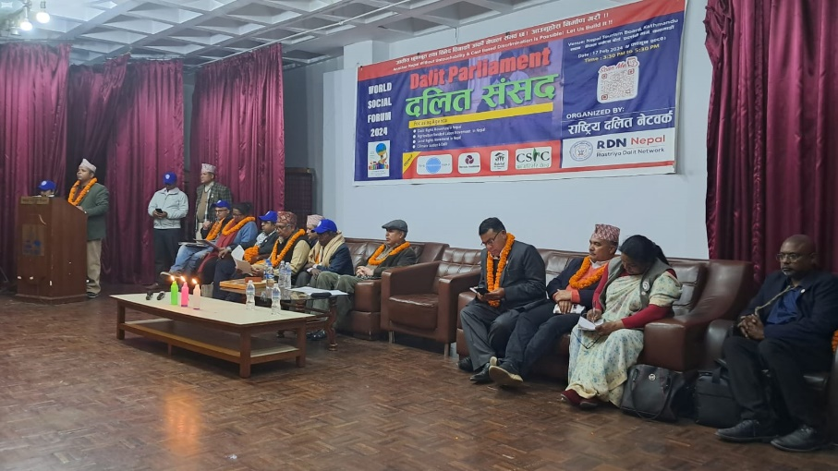
"When the state did not speak about the oppression of the Dalit community, the voice of Dalits was not heard from the Legislative Parliament, at that time we practiced the Dalit Parliament and made our voices heard," said Ganesh Bishwakarma, central chairperson of the Rastriya Dalit Network and also spokesman of Dalit Parliament. He further said, “Dalits are also represented in Parliament. But the Dalit community is forced to suffer untouchability. There are no excuses, the culprits have not been punished. There is no land. Deprived of education. We felt the need for a Dalit Parliament to solve all these problems.” They formed a 'Dalit Parliament' in Dhangadhi in 2000AD and debated the recent liberation and rehabilitation. After that, the Dalit Parliament lasted until the 11th series until the establishment of the Republic and the constitution. "Because the state parliament did not speak the voice of Dalits, now the situation has come that Dalits have to run their own parliament," President Bishwakarma said, "The Dalit parliament woke up in the context of the World Social Forum. Our conclusion is that a Nepal without caste discrimination is possible. Human society is possible without all kinds of discrimination and injustice.

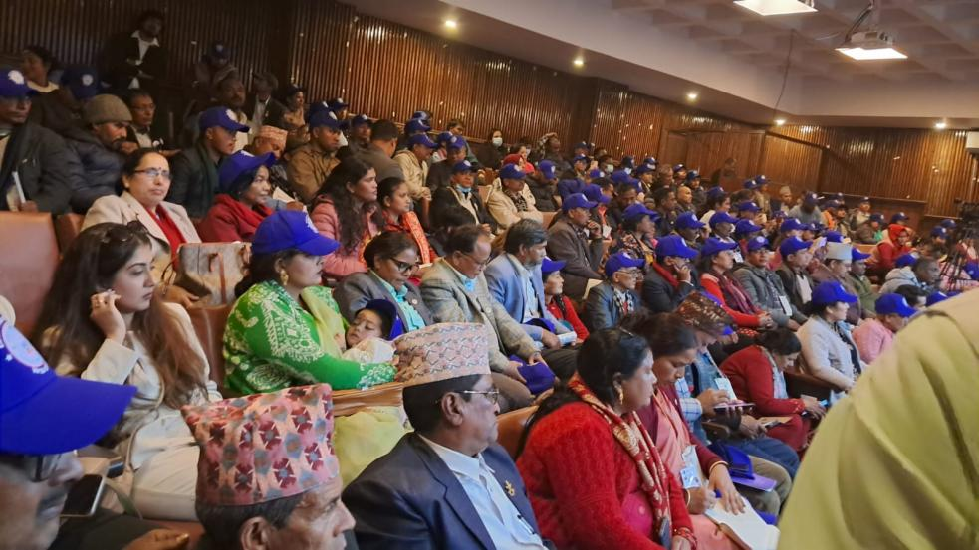
According to him, the Dalit Parliament should give the Dalit community the right to property. Human dignity and respect should be given. For that, it is necessary to bring this movement to a conclusion through class struggle. Dalit leaders, rights activists and people of the land narrated the stories of pain, experience, struggle and movement in the Dalit parliament held at the Bhrikutimandap under the umbrella of the World Social Forum.

The Parliament has passed various proposals to the world community on 9 points and to the Nepalese government on 16 points. In the same program, Paul Diwakar, the president of the World Forum of the communities suffering from caste discrimination, said that today's world is not free from discrimination and violence, and we have to fight for another world. Today's modern world is also going through caste system. I am from India, there are friends here from South Asia and many other countries," he said before, "The problem of caste is not only in Nepal or India or South Asia, it is all over the world. This is not only a problem of Dalits or Nepalis or Indians, it is a stigma on the entire human community. All the oppressed communities should now be united in solving such a problem. He said that today's global human community must fight against discrimination based on caste, color and slavery.

"There is no special religion, there is no different situation in any country, there is no lack of discrimination between people in developed countries," he said. Secretary Dr. Philip Vinod Picak said that oppressed communities should be able to rebel.

In the program, Shyam Shrestha, member of the Constituent Assembly and coordinator of the Study Committee on Free Kamaiya, Kamlari, Haliya and Harwacharwa, said that there are many forms of caste discrimination against Dalits in Nepal. He said that Dalits were deprived of education, health, land property and public administration by not only denying water, but still the culmination of such discrimination has not been completely eradicated.

Nira Jairu, a former member of the House of Representatives, shared her experience of not being able to do much for the empowerment of the Dalit community even though she was in the Constituent Assembly. I reached there with the will to do many things for the liberation of Dalits. But our efforts were continuously failed," she said, "I am sad that I was not able to fight even after reaching the leadership.

Hari Sripaili, a member of the Constituent Assembly, criticized the Dalit community for making all kinds of contributions to the country's political change, but there has been no change in practice. "Parties used the anger and strength of Dalits, they used it in agitations, but when they reaped the rewards, there was no general representation of the Dalit community," he said. "The situation has not improved much today compared to yesterday." "Neither an effective role has been given in the parliament, nor responsibility has been given in the government," he said, "The parties have only made a ladder for the Dalit community." Neither do any work for their upliftment, nor any opportunity to do it.

Annex-I (Kathmandu Declaration of Dalit Parliament):

The socialist direction of the Nepali Dalit movement
Kathmandu Declaration 2024 issued by
Dalit Parliament
Preamble:

We have issued this Kathmandu Declaration from the Dalit Parliament which was held on 17th February, 2024 in the presence of the progressive people of the socialist movement in Nepal and around the world with the main slogan; “Another Nepal without caste based discrimination and untouchability is possible, Let us build it.” It would organized in the context of World Social Forum (WSF) Nepal 2024 considering the non-implementation of the human rights provisions of Charter of the United Nations, Universal Declaration of Human Rights (1948), Declaration of Civil and Political Rights (1966), Declaration of Social, Cultural and Economic Rights (1966), International Convention on the Elimination of All Forms of Racial Discrimination (1965), Convention on the Elimination of All Forms of Discrimination against Women ( 1979), Convention on the Rights of the Child (1989), International Humanitarian Law (1949), Slavery Convention (1926) for the Dalits and the continued decline in incidents of caste discrimination and untouchability and also remaining steadfast in the implementation of the historic declarations and decisions of the Dalit Parliament since 2000 AD to till now led by Rastriya Dalit Network (RDN) Nepal.

This Dalit Parliament,
With respect to the 16th edition of the World Social Forum, which is being held recently with the main slogan "Another world is possible.” the first time in Nepal from 15th to 19th February 2024 with the involvement of 1252 organizations and groups from 92 countries around the world which have organized more than 400 programs in large and small, based on 13 main themes with the participation of thousands of people,

Demanding to re-evaluate policies, rules, plans, implementation levels and all other processes related to issues connected to world economy and politics, based on the political, economic and social characteristics of the laborer Dalit community, today's global economic crisis, epidemic crisis and climate crisis and class, regional, gender and drawing the serious attention of governments around the world to caste based discrimination and untouchability, this Dalit Parliament expresses solidarity with the issues to human rights and social justice expressed through the World Social Forum with the aim of creating pressure on the state to address the issues related to laborer Dalits around the world,

We would like to express our serious concern on behalf of all the Dalits of Nepal and the laborer community around the world by passing resolutions of public importance regarding the 21-point demands put forward by the Joint Political Dalit Struggle Committee, the 16-points resolution on Dalits passed by the National Assembly of Nepal, the study report on the situation of freed Kamaiya, Kamalari, Haliya and Harawa-Charawa 2078, the rehabilitation procedure and action plan for Kamaiya workers (Kamaiya, Kamalari, Halia and Harawa-Charawa) and related to forced labor (prohibition and rehabilitation).

Before the world community:
- We demand to be critical about the negative effects created by the accepted policies and structures, to create alternative thoughts and ideas and to create a new world order and corresponding policy-structures by expressing solidarity with the collective intervention of social movements and civil organizations around the world against all kinds ofdiscrimination and violence, multilateral poverty, extreme inequality, racial untouchability and discrimination based on apartheid, gender discrimination, sexuality and sexuality, caused by imperialism, neoliberalism, globalized financial capitalism, climate crisis.
- We invite you to keep humanity, freedom, self-respect and prosperity in the highest place in the world as profiteers are amassing wealth by selling the global crisis itself in today's capitalism, Internal migration from rural to urban areas is now moving from poor countries to developed countries. As wealth, technology and power are concentrated in the hands of the limited people of the world,
- We invite you to take care of the global crisis due to the genocide of the Israel-Hamas war from the Russia-Ukraine war to the judicial world as the right-wing extremist forces are under various pretexts to undermine the democratic process, society and the interests of the world by increasing militarization, refugee problems, migration and unemployment, wars and conflicts to fulfill their vested interests.
- We invite you to unite for the restoration of the rights of marginalized communities, including farmers, workers, women, Dalits, tribals, Muslims, youth, people with disabilities, gender and sexual minorities, and citizens affected by the epidemic, who have been deprived of the negative effects created by the policies and structures adopted by today's world system.
- The impact of climate change created by development that has adversely affected the environment has been severe in poor countries today. It is clear in front of us that the citizens of poor countries are getting into trouble through various means, but the limited amount of corporate houses are being built when rich countries are over-centralizing resources, means and opportunities due to exploitation, oppression and hegemonic policies. Therefore, we invite you to proceed in a planned manner for envisioning a new world order with human dignity based on equality and social justice, accessible to all.
- We request the governments around the world to formulate policies in favor of the laborer Dalit community through positive debate about the effects of discrimination based on race, descent and birth, caste system and caste system, discrimination based on color, deprivation, climate change, disaster and inequality on Dalit and marginalized communities.
- We request the World Social Forum to prepare a strategy with a concrete plan of struggle for the achievement of the desired peaceful world with justice, equality, freedom and human dignity, preparing a clear blueprint for its governance, economy, social system and the quality of life of the citizens.
- A total of 15.1% of people in Nepal are still below the poverty line. In other words, 45 million people are still in need of food and shelter those who earn less than USD 1.90 per day. Another 1.5 million people are without access to electricity. According to a food security survey conducted in 2016, a total of 4.6 million people are still vulnerable to food security in Nepal. There are still about 1 million children in menial labor. 40% of citizens still do not have access to health services. Every year 1 million people go to India and other countries in search of work. There is unemployment in the country, there is no equitable development, ethnic and regional differences are strong, corruption is rampant, and the state has not become just, inclusive and democratic. In such a situation, a just and prosperous Nepal and a democratic, equitable, inclusive, corruption-free Nepal where no one is hungry, no one is naked, no one is homeless, everyone gets a job, no one is left behind on the basis of caste, religion, caste, gender, region, freedom for all. In this regard, we request you to declare your commitment to the world community to resolve to restore self-respect.
- We demand to pass the protocol or declaration on Dalits through the United Nations in order to open up the collective identity of the communities including Dalits who are victims of caste discrimination around the world.

Before the Government of Nepal:
- We demand to arrange at least 20% constitutional scientific reservation on the basis of Dalit population in all bodies including representative, constitutional and other administrative areas of the state of Nepal. Also, we demand to implement the policy of "reservation within the reservation" for the protection, empowerment and development of Madhesi, Newari and Karnali Dalits, Badi and Dalit women within the Dalit community.
- We demand for the revolutionary land reform package including reforms in the traditional agricultural system to solve all the issues related to the land of Dalits, and an appropriate policy should be formulated to ensure ownership of the land by Dalits and effective implementation by implementing the recommendations of the High Level Land Rights Commission.
- We demand to amend the constitution to ensure proportional representation of the Dalit community at the local, provincial and federal level to create a 'integrated law on Dalits' accordingly and According to the principle of proportional inclusiveness provided in the Constitution of Nepal, to form a ‘Dalit Development Authority' for the overall development of the Dalit community according to the principle of proportional inclusiveness provided in the Constitution of Nepal.
- We demand that Dalit women participate in every field and make a constitutional and legal arrangement for 50% scientific reservation for common women and 20% of that for Dalit women.
- It is demanded to plan and implement the overall development of the Badi community in order to put an end to the political, economic and socio-cultural oppression of the Badi community according to the agreement between the Badi rights movement and the government.
- We demands that a separate Dalit cell should established in all police offices on the issue of untouchability and discrimination by arranging the sufficient budget to address cases of public humiliation, rape, murder, violence, beatings, public blockades and boycotts against the Dalit community due to caste-related untouchability and discrimination through the fast-track method based on the zero-tolerance policy and to effectively implement the Caste-related Untouchability and Discrimination (Crimes and Punishments) Act-2068.
- We demand that the branch offices should be opened in all provinces, Dalit Development Divisions in all ministries at federal and Province level and 'Dalit Development Branches' at all local municipalities for the overall development and empowerment of the Dalit community by making the National Dalit Commission powerful with sufficient resources, as per the provision in the Constitution of Nepal.
- We demand to upgrade the Bijeshwori Social Development Hostel in Kathmandu as a central hostel for logistic arrangement of women and for arranging hostels for Dalit community students in the main cities of all provinces in Nepal.
- It is demanded to establish a 'Multi-Purpose Skills and Arts Technical School' to protect and promote the skill and profession of Dalits since the skills, arts and abilities of the Dalit community are the property of the state and the manpower is experienced as engineers.
- Even though the end of feudalism has been declared in Nepali society, the Dalit population affected by Khalo-practice, Doli-practice, Haliya-practice, Harawa-Charawa-practice, which are the remnants of feudalism, are demanded to be rehabilitated immediately and arrange for self-sufficient production with alternative employment.
- We invite for people's movements to unite against the extreme right-wing and populist forces that are dominating the Nepali politics and creating unnecessary confusion in the society and leading to regression and weakening the socialist movement.
- We demand to pass and implement the Report of the Study Committee on the Situation of Freed Kamaiya, Kamalari, Haliya and Harwa-Charawa 2078 formed by Nepal Government Ministry of Land Management, Cooperatives and Poverty Alleviation, Rehabilitation procedure and action plan for Kamaiya workers (Kamaiya, Kamlari, Halia and Harawa-Charawa) and forced labor (prohibition and rehabilitation Bill 2079 immediately.
- We demand that the Untouchabilioty freed day should be declared as Dalit Rights Day and the decade from 2024 to 2034 should be declared as 'Dalit Rights Decade' by strongly condemning all kinds of casteism, caste discrimination and untouchability based on caste, recognizing that any kind of discrimination based on caste and untouchability are scientifically wrong, socially reprehensible and dangerous and punishable from legal point of view.
- We request to provide land to landless squatters where they are living and using at least 2 kattha for housing and 8 kattha for farming according to the formation order of the National Land Commission, when starting the work for landless squatters, to give first priority to the landless squatters, while collecting and verifying the data of the landless squatters, defining the landless squatters as a special community, defining the landless squatters as a special community as much as possible in the place.
- We demand to establish of a labor bank to implement the slogan of one working family, one job, and the establishment of a labor welfare fund for the sustainability of agricultural laborers
- The Dalit Parliament held on the third day of the World Social Forum would like its gratitude to all the speakers for attending the Dalit Parliament from home and abroad for expressing their important views as important speakers.

